**Objects**

In this tutorial we will understand what, is an object in the real world and in programming world.

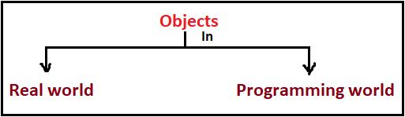

1. [objects in real world.](objects%20in%20real%20world.docx)
2. [objects in JavaScript language.](objects%20in%20JS%20language.docx)